Alkene Synthesis of an Alcohol
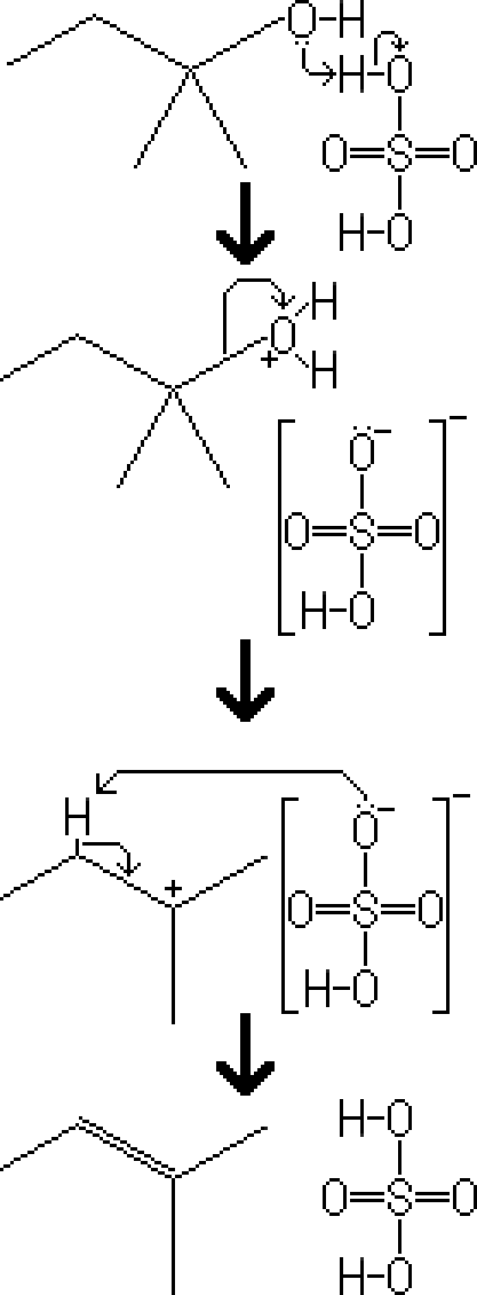
Reactants – Tertiary Alcohol, conc. H₂SO₄
Products – Alkene, H₂O, H2SO4
Electron Movement
- E2 Reaction – The electrons of the alcohol's oxygen attack one of the hydrogen atoms from the sulfuric acid. The water attached to the compound acts as a good leaving group and is removed. A negatively charged hydrogen sulfate ion attacks a proton on the most branched beta carbon, and the electrons are distributed to the carbon-carbon bond, resulting in an alkene.

